**ADVANCE EXCEL ASSIGNMENT - 6**

**Q1. What are the various elements of the Excel interface? Describe how they're used.**

**Ans.** The Excel interface is composed of several elements that help users navigate, enter data, and perform various tasks. Here are the key elements of the Excel interface and how they are used:

1. **Ribbon:** The Ribbon is the tabbed toolbar at the top of the Excel window. It contains tabs such as Home, Insert, Page Layout, Formulas, Data, Review, and View. Each tab has groups of related commands.
2. **Quick Access Toolbar:** The Quick Access Toolbar is a customizable toolbar located above the Ribbon. Users can add frequently used commands to this toolbar for quick access.
3. **Workbook:** A workbook is the main document in Excel, and it consists of one or more worksheets. Users can switch between different sheets within a workbook, and each sheet contains cells arranged in columns and rows.
4. **Worksheet:** A worksheet is a single tab within a workbook. It is a grid of cells where users enter and manipulate data. Each column is labelled with a letter, and each row is labelled with a number. The intersection of a row and column is a cell.
5. **Columns and Rows:** Columns run vertically and are labelled with a letter (A, B, C, ...). Rows run horizontally and are labelled with a number (1, 2, 3, ...). The combination of a column letter and a row number identifies a cell (e.g., A1, B2).
6. **Cells:** Cells are the individual units in a worksheet where data is entered. Users can input text, numbers, formulas, and functions into cells. The active cell, where data can be entered, is highlighted.
7. **Formula Bar:** The Formula Bar is located above the worksheet grid. It displays the contents of the active cell and allows users to enter or edit data directly. Formulas and functions can also be entered here.
8. **Name Box:** The Name Box is located next to the Formula Bar. It displays the cell reference or the name of the selected cell. Users can use this box to navigate quickly to specific cells by entering their references.Top of Form

**Q2. Write down the various applications of Excel in the industry.**

**Ans.** Excel is a versatile spreadsheet program widely used across various industries due to its powerful features and ease of use. Here are some common applications of Excel in the industry:

1. Business Intelligence
2. Data Analysis and Reporting
3. Data Visualization
4. Sports and Technologies
5. Financial Analysis
6. Project Management
7. Inventory Management
8. Human Resources
9. Sales and Marketing
10. Quality Control and Manufacturing
11. Education and Research
12. Logistics and Supply Chain Management
13. Real Estate and Property Management
14. Healthcare and many more.

**Q3. On the ribbon, make a new tab. Add some different groups, insert commands in the groups and name them according to their commands added. Copy and paste the screenshot of the steps you followed.**

**Ans.** The steps are as follows:

1. Right-click on the Ribbon and select "Customize the Ribbon..."

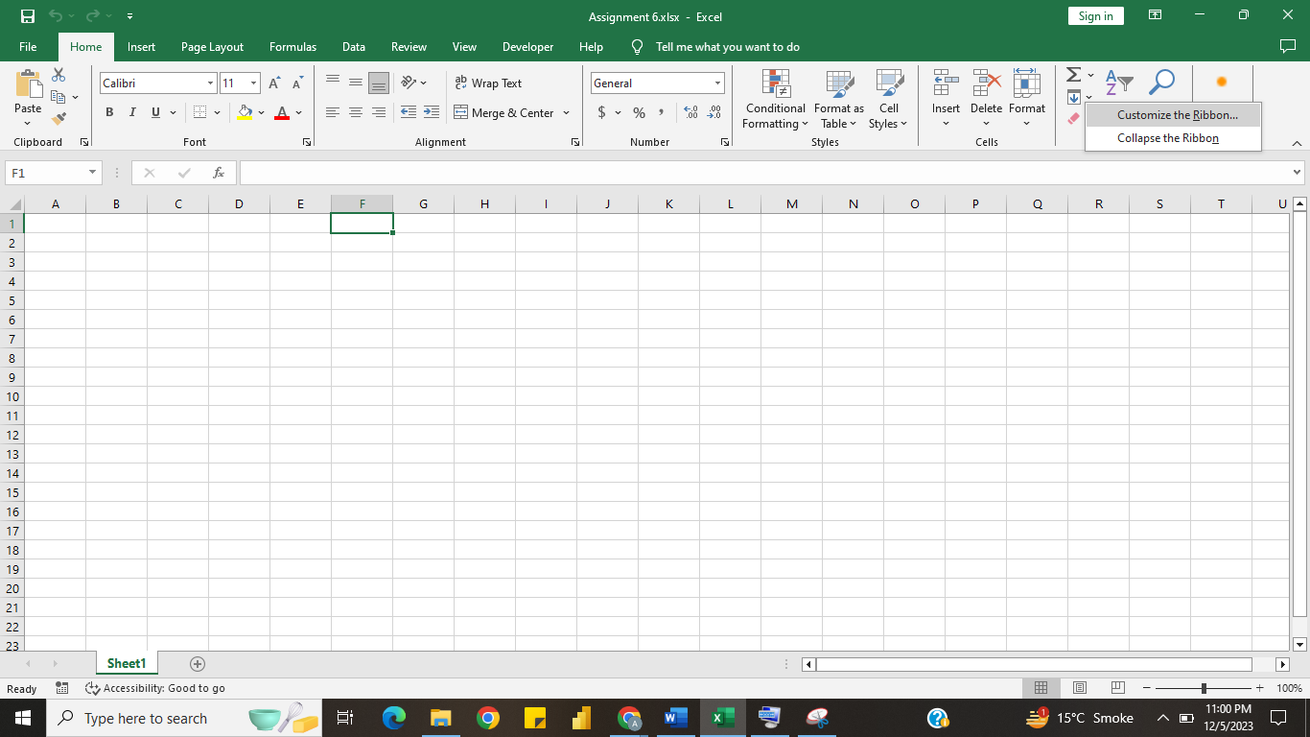

1. In the Excel Options dialog box, on the right side, you will see the list of Main Tabs. Click "New Tab."

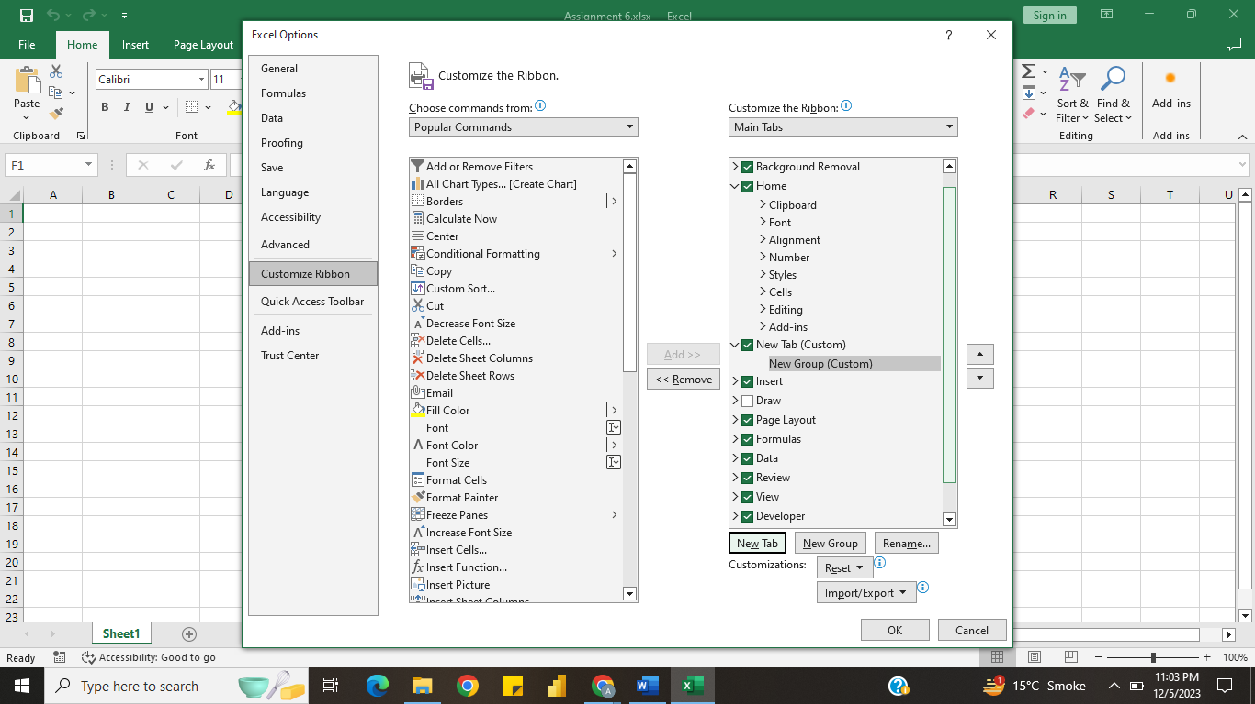

1. Select the new tab (New Tab (Custom)). Click "Rename..." to "Custom Tools".

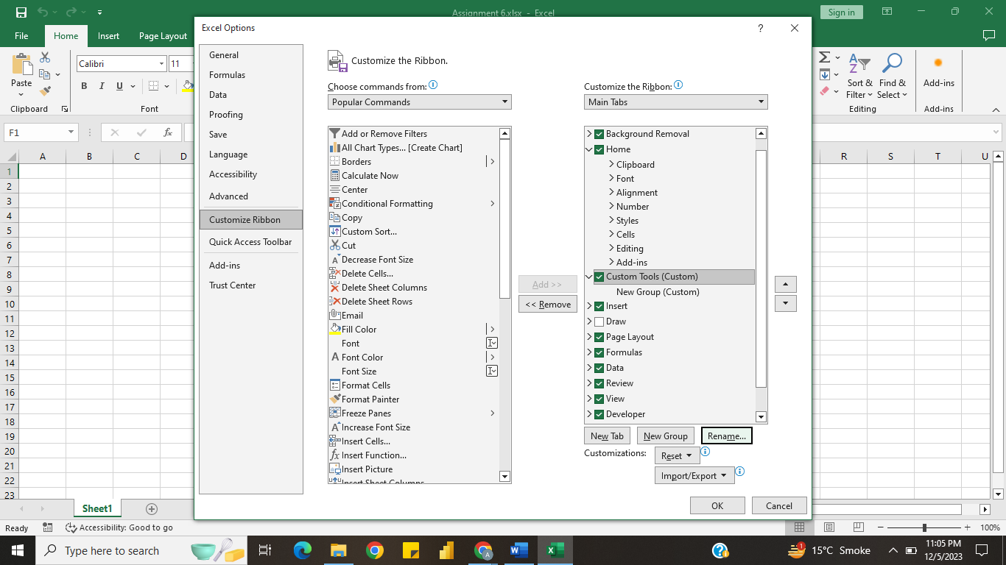

1. With your new tab selected, click "New Group" and rename it by clicking "Rename..." to "Data Analysis".

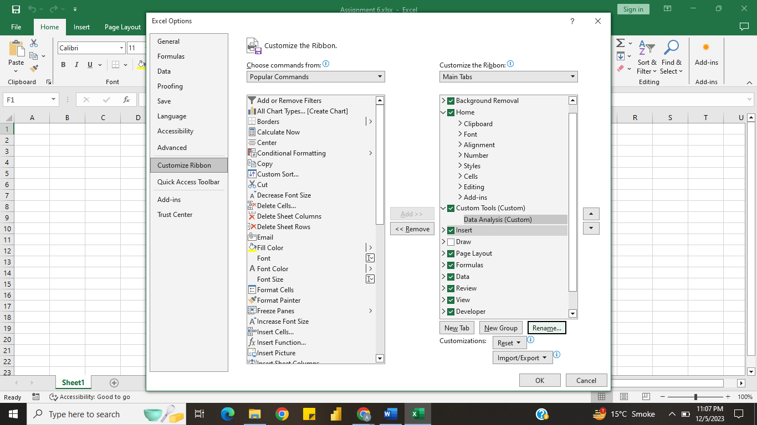

1. Select the group and choose the commands on the left side you want to add from the "Choose commands from" drop-down list. Click on the desired command and then click "Add > >" to add it to new group.

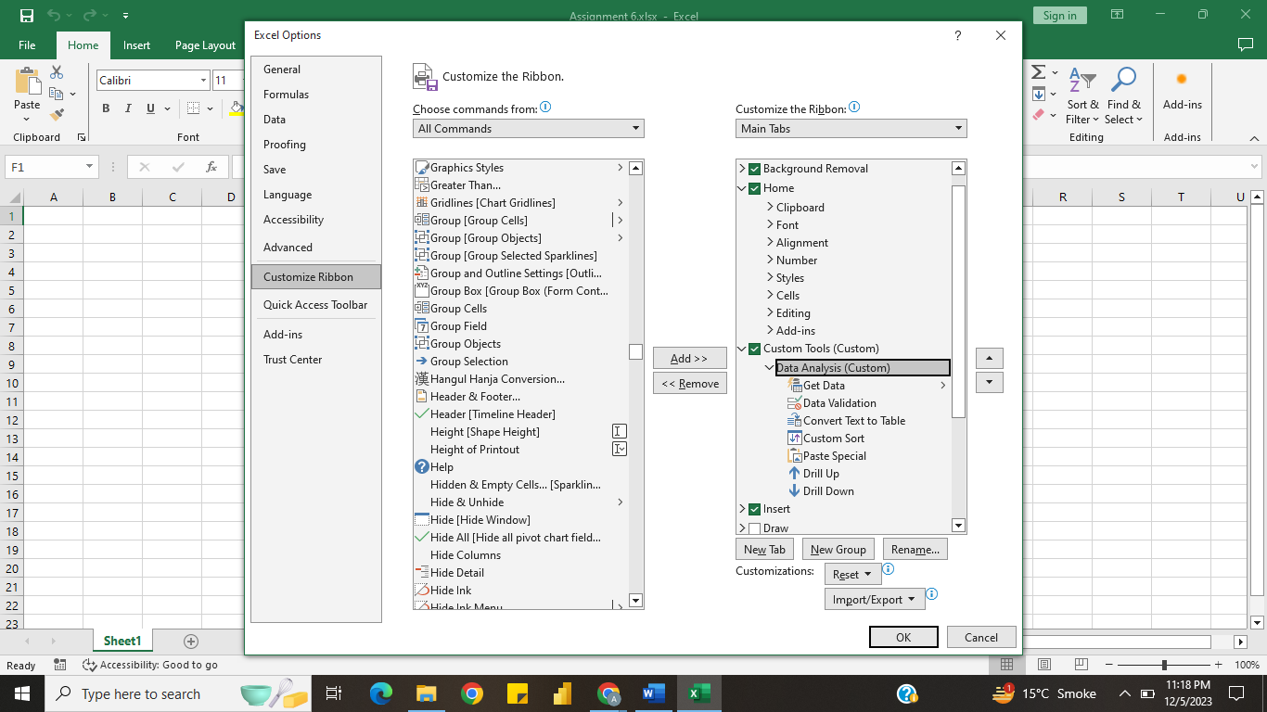

1. Click "OK" to apply your changes.

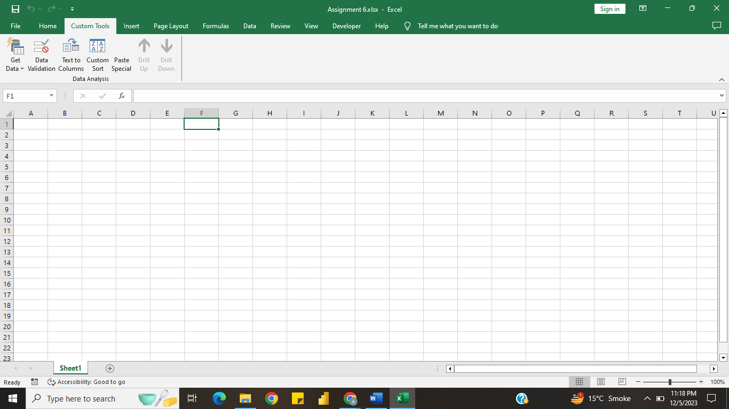

**Q4. Make a list of different shortcut keys that are only connected to formatting with their functions.**

**Ans.** List of some common shortcut keys in Excel that are specifically related to formatting are as follows:

1. **Ctrl + B:** Bold
2. **Ctrl + I:** Italic
3. **Ctrl + U:** Underline
4. **Ctrl + 1:** Opens the Format Cells dialog box
5. **Ctrl + Shift + $:** Applies the currency format to the selected cells
6. **Ctrl + Shift + %:** Applies the percentage format to the selected cells
7. **Ctrl + 5:** Applies or removes strikethrough formatting from the selected cells or text.
8. **Ctrl + Arrow Keys:** Navigate to the edge of the data region in the current direction (up, down, left, or right) without changing the selection.
9. **Alt + H, B:** Adds a double border to the selected cells.
10. **Alt + H, E, A:** Clears all formatting from the selected cells.

**Q5. What distinguishes Excel from other analytical tools?**

**Ans.** Excel is a widely used spreadsheet software in offices and industries for many years. While there are numerous analytical tools available, Excel distinguishes itself in several ways:

1. Versatility
2. User-Friendly Interface
3. Familiarity
4. Wide Adoption in Business
5. Formula and Function Capabilities
6. Ease of Data Entry and Manipulation
7. Charts and Graphs
8. Integration with Other Microsoft Office Applications
9. PivotTables and PivotCharts
10. Customization and Automation

Top of Form

**Q6. Create a table and add a custom header and footer to your table.**

**Ans.** **Creating a Table:**

1. Enter your data into the cells.
2. Select the range of cells and Press **“Ctrl + T”**. to convert the range into table. Check the box “My table has headers” and click on “OK”.

Now, the table is created.

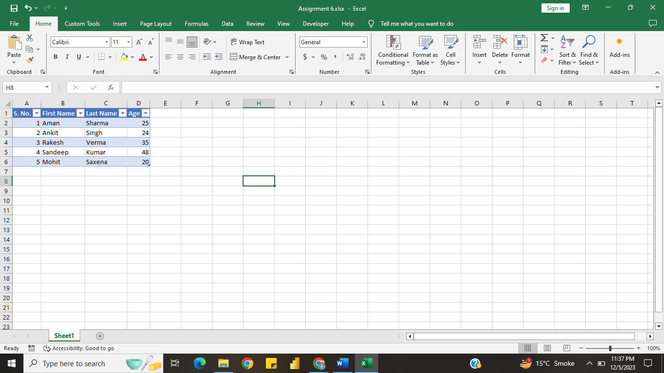

**Adding a Custom Header and Footer:**

1. Go to the "Insert" tab. Click on the "Header & Footer" button in the Text group.
2. The worksheet will switch to Page Layout view. You will see the Header & Footer Design Tools tab.
   * Click on the left, centre, or right section in the header or footer area to add text.
   * You can use the buttons on the Header & Footer Design Tools tab to insert page numbers, date, time, and other elements.

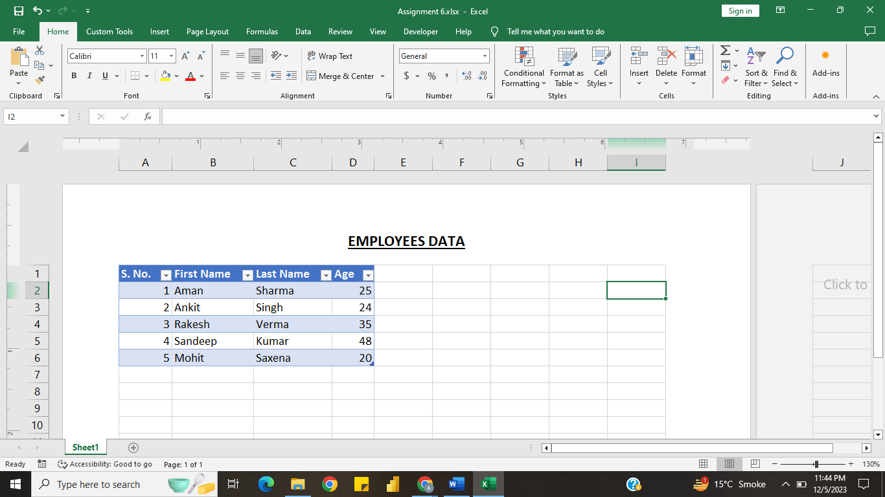

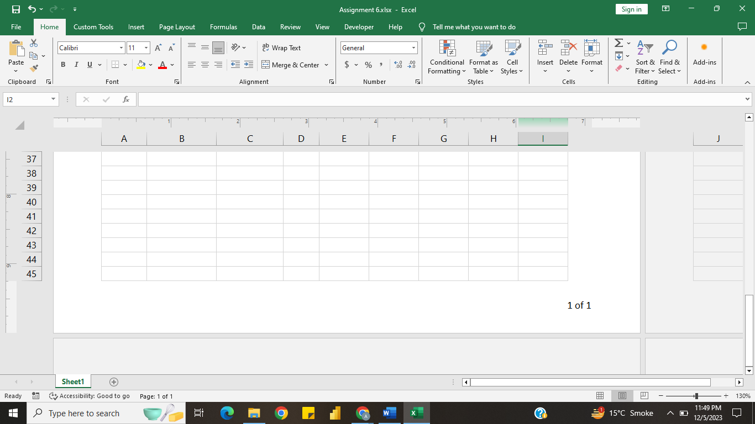

1. To exit the Header & Footer Design Tools tab, double-click anywhere outside the header/footer area or click the "Back to Normal View" button on the Ribbon.

Now, your table has a custom header and footer.Top of Form